SOP title Data Query

Version 1.0

Date issued 31Aug2016

Valid until 30Jun2017

Author(s) Name: Caesar Olima

Signature:

Date: 31Aug2016

Approved by Name:

Signature

Date

Modification history

Version No | Date | Author(s) | Date reissued to previous recipients

Standard Operating Procedure

- Purpose
The purpose of this standard operating procedure (SOP) is to ensure that data recorded on the CHAIN study electronic Case Report Forms (eCRFs) are regularly monitored for accuracy, completeness and compliance with the protocol.

- Scope
This SOP describes the process for generating and resolving the CHAIN study data queries on REDCap database.

- Responsibility
Trial staff are responsible for ensuring the necessary data are complete and accurate on the electronic case record form (eCRF). Trial staff are also responsible for amending any data queries raised by the database or by a Monitor or Data Manager. Details of the monitoring activities are given in a separate document.

- Procedure
  - Raising data queries
    - Data queries can be:
- Generated automatically by REDCap (these are either missing or irregularity data queries); or
- Raised by Data Entry staff during data entry of eCRFs/CRFs or by a Monitor, Data Reviewer or Data Manager whilst reviewing eCRFs e.g. during source data verification (these are manual data queries).
    - To raise a manual irregularity data query:
      - Click on the bubble icon (highlighted below), next to the field you would like to raise a query on.
      - Select “Open Query” and provide some comments that would help in resolving this query.
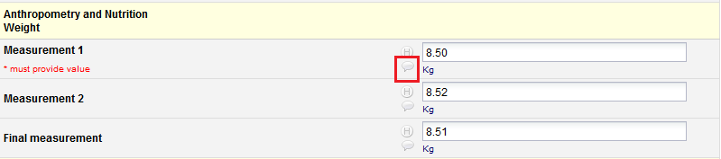

  - Resolution of data queries
    - A staff member (with REDCap data entry role) will need to resolve each query by completing one of the following:
- Amend to the correct value or information.
- Add new or additional information.
- Provide additional clarification. For example, when it is deemed necessary to overrule a database warning, this should be done and the reason should be stated.
- Confirm data are missing/unobtainable. The associated missing eCRF and/or fields should be indicated as such on the database and amended to ‘incomplete’.
It is important to remember that overriding warnings and setting data to missing or unobtainable may result in a protocol deviation. Please check the protocol and if necessary report findings to the trial co-ordinator.
    - To view and resolve missing data queries:
Any user with 'respond' privileges will be able to respond to an open query (even if it is assigned to a specific user). The responder may select a response type (i.e. Corrected-Data missing) and provide a descriptive comment with the ability to also attach a file (optional). Once a query has been responded to, a user with 'close' privileges may close the query, after which it will be considered resolved.

    - Process for viewing and resolving irregularity data queries:
Any user with 'respond' privileges will be able to respond to an open query (even if it is assigned to a specific user). The responder may select a response type (i.e. Corrected-Typographical error) and provide a descriptive comment with the ability to also attach a file (optional). Once a query has been responded to, a user with 'close' privileges may close the query, after which it will be considered resolved.

    - Process for viewing and resolving manual irregularity data queries:
Any user with 'respond' privileges will be able to respond to an open query (even if it is assigned to a specific user). The responder may select a response type (i.e. Data missing) and provide a descriptive comment with the ability to also attach a file (optional). Once a query has been responded to, a user with 'close' privileges may close the query, after which it will be considered resolved.

    - Process for viewing and resolving range check data queries:
Any user with 'respond' privileges will be able to respond to an open query (even if it is assigned to a specific user). If the previously entered data is out of the accepted validation range but has been confirmed from the source document as the true recorded value, then responder may select a response type (i.e. Verified- Confirmed correct (no error)) and provide a descriptive comment, with the ability to also attach a file (optional). Once a query has been responded to, a user with 'close' privileges may close the query, after which it will be considered resolved.

- References
  - SOPs:
  - CHAIN Data Entry V1.0 31Aug2016

